# 9.ReactJS Hands-on Lab Solution – cricketapp

## 1. ListofPlayers Component

Create a React component to list 11 players using ES6 map() and filter those with scores below 70 using arrow functions.

Code:

const ListofPlayers = () => {  
 const players = [  
 { name: "Player1", score: 85 },  
 { name: "Player2", score: 60 },  
 { name: "Player3", score: 72 },  
 { name: "Player4", score: 55 },  
 { name: "Player5", score: 90 },  
 { name: "Player6", score: 45 },  
 { name: "Player7", score: 70 },  
 { name: "Player8", score: 95 },  
 { name: "Player9", score: 50 },  
 { name: "Player10", score: 88 },  
 { name: "Player11", score: 66 },  
 ];  
  
 const lowScorers = players.filter(player => player.score < 70);  
  
 return (  
 <div>  
 <h2>All Players</h2>  
 <ul>{players.map(p => <li key={p.name}>{p.name}: {p.score}</li>)}</ul>  
 <h3>Players with score below 70</h3>  
 <ul>{lowScorers.map(p => <li key={p.name}>{p.name}: {p.score}</li>)}</ul>  
 </div>  
 );  
};

## 2. IndianPlayers Component

Use destructuring and merge arrays to display Odd and Even Team Players.

Code:

const IndianPlayers = () => {  
 const oddTeam = ["Kohli", "Rohit", "Rahul", "Hardik", "Pant"];  
 const evenTeam = ["Jadeja", "Shami", "Bumrah", "Ashwin", "Gill"];  
  
 const [p1, p2, p3, p4, p5] = oddTeam;  
 const [q1, q2, q3, q4, q5] = evenTeam;  
  
 const T20players = ["Surya", "Iyer"];  
 const RanjiTrophy = ["Pujara", "Rahane"];  
 const merged = [...T20players, ...RanjiTrophy];  
  
 return (  
 <div>  
 <h2>Odd Team Players</h2>  
 <ul><li>{p1}</li><li>{p2}</li><li>{p3}</li><li>{p4}</li><li>{p5}</li></ul>  
 <h2>Even Team Players</h2>  
 <ul><li>{q1}</li><li>{q2}</li><li>{q3}</li><li>{q4}</li><li>{q5}</li></ul>  
 <h3>Merged T20 + Ranji Players</h3>  
 <ul>{merged.map((name, index) => <li key={index}>{name}</li>)}</ul>  
 </div>  
 );  
};

## 3. App.js – Conditional Display with Flag

Code:

import ListofPlayers from './ListofPlayers';  
import IndianPlayers from './IndianPlayers';  
  
const App = () => {  
 const flag = true; // change to false to test alternate view  
  
 return (  
 <div>  
 <h1>Cricket App</h1>  
 {flag ? <ListofPlayers /> : <IndianPlayers />}  
 </div>  
 );  
};  
  
export default App;

**OUTPUT:**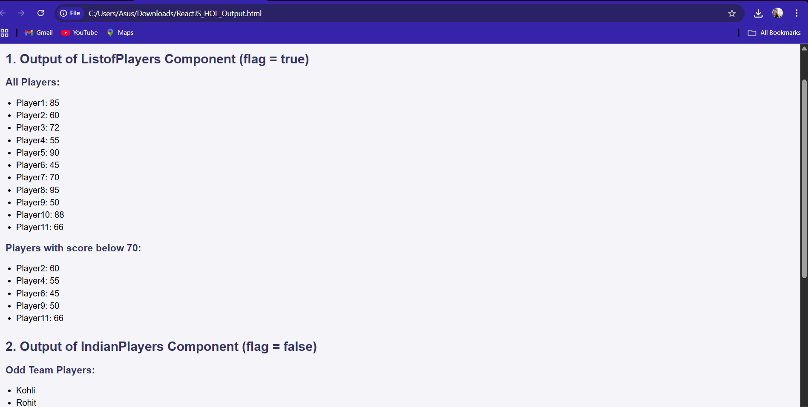

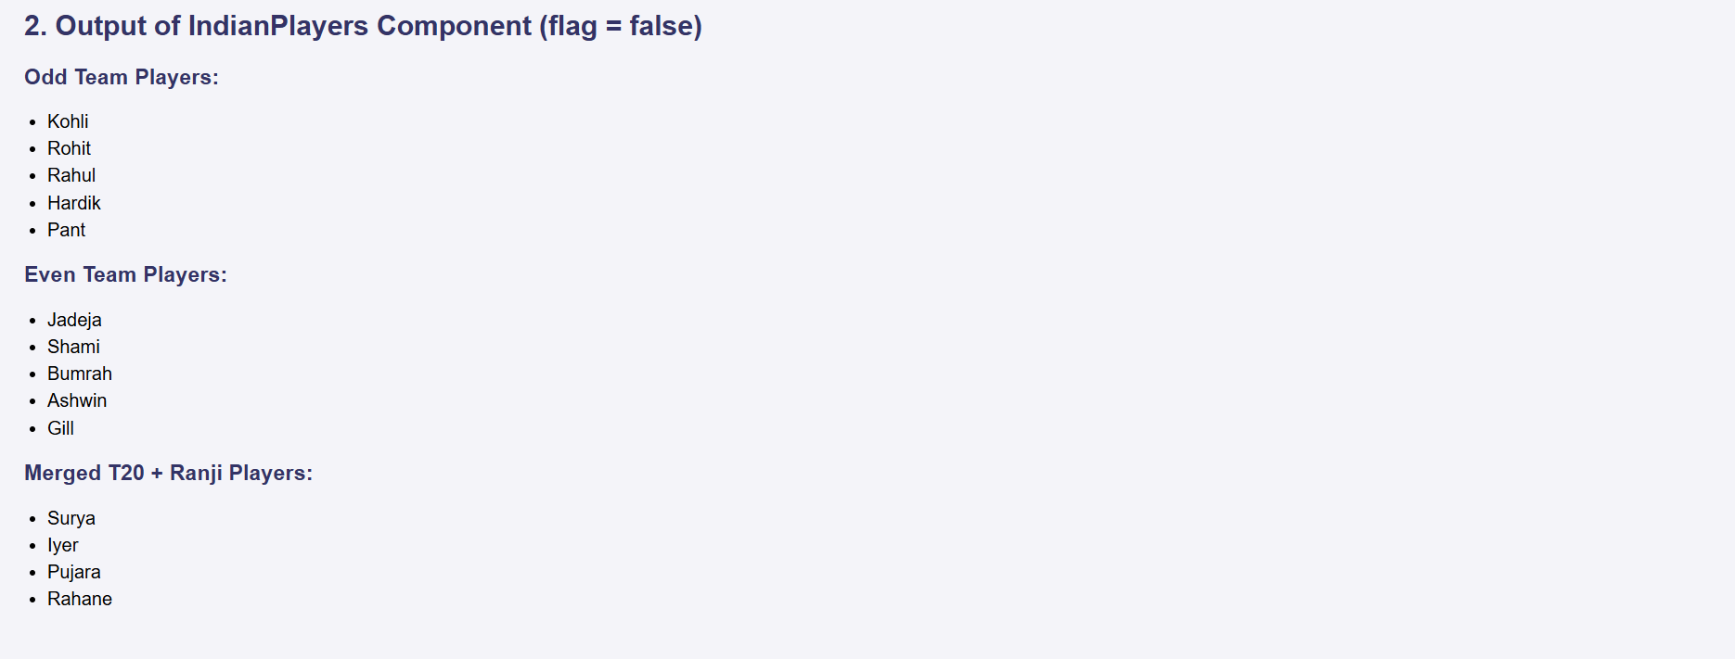

10.ReactJS Hands-on Lab Solution

# React Code

Below is the main code for the `App.js` file in your React project:

import React from 'react';  
import './App.css';  
  
function App() {  
 const officeSpaces = [  
 { name: "IndiQube Alpha", rent: 55000, address: "Koramangala, Bangalore" },  
 { name: "WeWork Galaxy", rent: 75000, address: "MG Road, Bangalore" },  
 { name: "91Springboard", rent: 48000, address: "HSR Layout, Bangalore" },  
 { name: "Regus", rent: 62000, address: "Whitefield, Bangalore" }  
 ];  
  
 const rentStyle = (rent) => ({  
 color: rent < 60000 ? 'red' : 'green',  
 fontWeight: 'bold'  
 });  
  
 return (  
 <div className="App">  
 <h1>Office Space Rental App</h1>  
 <img src="https://via.placeholder.com/600x200" alt="Office" />  
 <ul>  
 {officeSpaces.map((office, index) => (  
 <li key={index}>  
 <p><strong>Name:</strong> {office.name}</p>  
 <p style={rentStyle(office.rent)}><strong>Rent:</strong> ₹{office.rent}</p>  
 <p><strong>Address:</strong> {office.address}</p>  
 <hr />  
 </li>  
 ))}  
 </ul>  
 </div>  
 );  
}  
  
export default App;

**OUTPUT:**

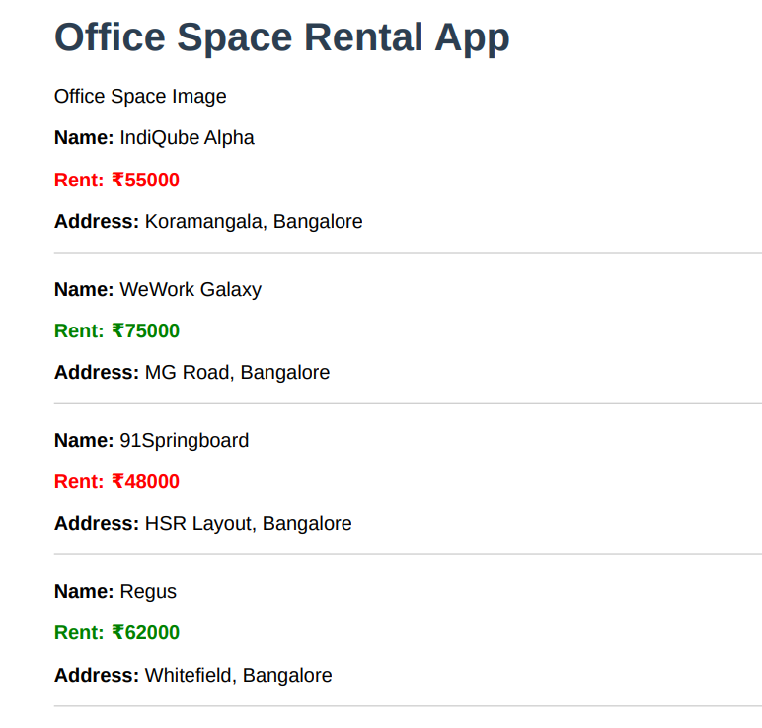

11.ReactJS Event Handling Hands-on Lab Solution

# App.js Implementation

Replace the contents of App.js with the following code:

import React, { useState } from 'react';  
import './App.css';  
import CurrencyConvertor from './CurrencyConvertor';  
  
function App() {  
 const [count, setCount] = useState(0);  
  
 const increment = () => {  
 setCount(count + 1);  
 sayHello();  
 };  
  
 const decrement = () => {  
 setCount(count - 1);  
 };  
  
 const sayHello = () => {  
 console.log("Hello! This is a static message.");  
 };  
  
 const sayWelcome = (msg) => {  
 alert(msg);  
 };  
  
 const handlePress = () => {  
 alert("I was clicked");  
 };  
  
 return (  
 <div className="App">  
 <h1>React Event Handling</h1>  
 <h2>Counter: {count}</h2>  
 <button onClick={increment}>Increment</button>  
 <button onClick={decrement}>Decrement</button>  
 <br /><br />  
 <button onClick={() => sayWelcome("Welcome!")}>Say Welcome</button>  
 <br /><br />  
 <button onClick={handlePress}>Press Me</button>  
 <br /><br />  
 <CurrencyConvertor />  
 </div>  
 );  
}  
  
export default App;

# CurrencyConvertor.js Implementation

Create a new file named CurrencyConvertor.js in the src folder and add the following code:

import React, { useState } from 'react';  
  
function CurrencyConvertor() {  
 const [rupees, setRupees] = useState('');  
 const [euros, setEuros] = useState('');  
  
 const handleChange = (e) => {  
 setRupees(e.target.value);  
 };  
  
 const handleSubmit = () => {  
 const converted = parseFloat(rupees) * 0.011; // Rough conversion rate  
 setEuros(converted.toFixed(2));  
 };  
  
 return (  
 <div>  
 <h2>Currency Convertor</h2>  
 <input type="number" value={rupees} onChange={handleChange} placeholder="Enter amount in INR" />  
 <button onClick={handleSubmit}>Convert</button>  
 {euros && <p>{rupees} INR = {euros} EUR</p>}  
 </div>  
 );  
}  
  
export default CurrencyConvertor;

**OUTPUT:**

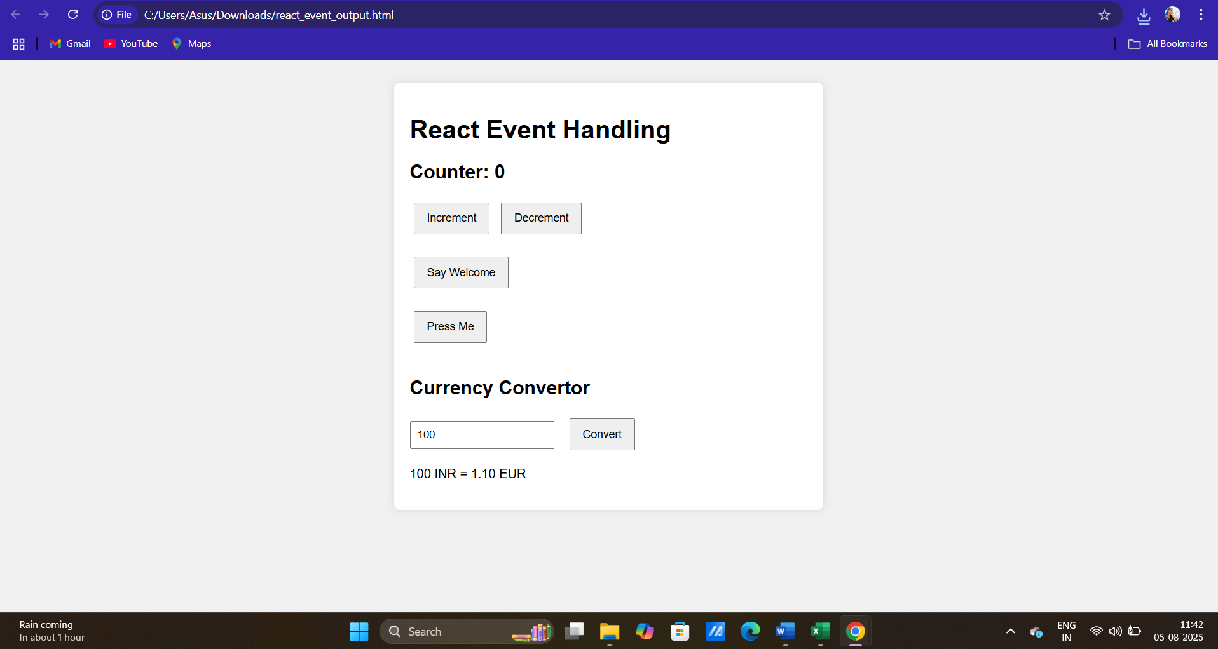

**12.ReactJS Conditional Rendering Hands-on Lab Solution**

**App.js Implementation:**

import React, { useState } from 'react';

import './App.css';

function App() {

const [isLoggedIn, setIsLoggedIn] = useState(false);

const handleLogin = () => {

setIsLoggedIn(true);

};

const handleLogout = () => {

setIsLoggedIn(false);

};

let content;

if (isLoggedIn) {

content = <UserPage onLogout={handleLogout} />;

} else {

content = <GuestPage onLogin={handleLogin} />;

}

return (

<div className="App">

<h1>Flight Ticket Booking App</h1>

{content}

</div>

);

}

function GuestPage({ onLogin }) {

return (

<div>

<h2>Welcome Guest</h2>

<p>You can browse available flights.</p>

<button onClick={onLogin}>Login</button>

</div>

);

}

function UserPage({ onLogout }) {

return (

<div>

<h2>Welcome User</h2>

<p>You are now logged in. You can book your flight tickets.</p>

<button onClick={onLogout}>Logout</button>

</div>

);

}

export default App;

**ticket_booking_output.html:**

<!DOCTYPE html>

<html lang="en">

<head>

<meta charset="UTF-8">

<title>Ticket Booking App - Conditional Rendering</title>

<style>

body {

font-family: Arial, sans-serif;

background-color: #f8f9fa;

padding: 20px;

}

.container {

background: #fff;

padding: 20px;

border-radius: 10px;

box-shadow: 0 2px 8px rgba(0,0,0,0.1);

max-width: 600px;

margin: auto;

}

button {

padding: 10px 15px;

margin-top: 10px;

}

</style>

</head>

<body>

<div class="container" id="app">

<h1>Flight Ticket Booking App</h1>

<div id="content">

<h2>Welcome Guest</h2>

<p>You can browse available flights.</p>

<button onclick="login()">Login</button>

</div>

</div>

<script>

function login() {

document.getElementById('content').innerHTML = `

<h2>Welcome User</h2>

<p>You are now logged in. You can book your flight tickets.</p>

<button onclick="logout()">Logout</button>

`;

}

function logout() {

document.getElementById('content').innerHTML = `

<h2>Welcome Guest</h2>

<p>You can browse available flights.</p>

<button onclick="login()">Login</button>

`;

}

</script>

</body>

</html>

**OUTPUT:**

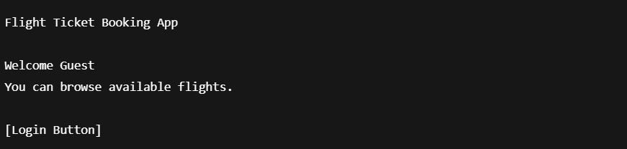

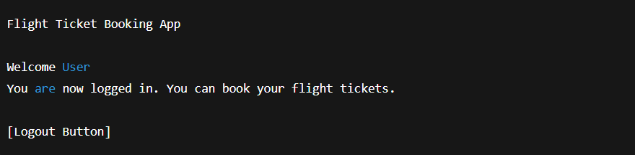

**13.ReactJS Conditional Rendering with Lists and Keys – Hands-on Lab Solution**

**App.js**

import React, { useState } from 'react';

import './App.css';

import BookDetails from './BookDetails';

import BlogDetails from './BlogDetails';

import CourseDetails from './CourseDetails';

function App() {

const [activeComponent, setActiveComponent] = useState('book');

const renderComponent = () => {

switch (activeComponent) {

case 'book':

return <BookDetails />;

case 'blog':

return <BlogDetails />;

case 'course':

return <CourseDetails />;

default:

return null;

}

};

return (

<div className="App">

<h1>Blogger App</h1>

<button onClick={() => setActiveComponent('book')}>Book Details</button>

<button onClick={() => setActiveComponent('blog')}>Blog Details</button>

<button onClick={() => setActiveComponent('course')}>Course Details</button>

<hr />

{renderComponent()}

</div>

);

}

export default App;

**BookDetails.js**

import React from 'react';

function BookDetails() {

const books = [

{ id: 1, title: 'The Alchemist', author: 'Paulo Coelho' },

{ id: 2, title: 'Atomic Habits', author: 'James Clear' },

{ id: 3, title: 'Deep Work', author: 'Cal Newport' },

];

return (

<div>

<h2>Book Details</h2>

<ul>

{books.map(book => (

<li key={book.id}>{book.title} by {book.author}</li>

))}

</ul>

</div>

);

}

export default BookDetails;

**BlogDetails.js**

import React from 'react';

function BlogDetails() {

const blogs = [

{ id: 1, title: 'React Basics', date: '2025-01-10' },

{ id: 2, title: 'Understanding Hooks', date: '2025-02-15' },

];

return (

<div>

<h2>Blog Details</h2>

<ul>

{blogs.map(blog => (

<li key={blog.id}>{blog.title} - {blog.date}</li>

))}

</ul>

</div>

);

}

export default BlogDetails;

**CourseDetails.js**

import React from 'react';

function CourseDetails() {

const courses = [

{ id: 1, name: 'ReactJS Essentials', duration: '4 weeks' },

{ id: 2, name: 'Advanced JavaScript', duration: '6 weeks' },

];

return (

<div>

<h2>Course Details</h2>

<ul>

{courses.map(course => (

<li key={course.id}>{course.name} - {course.duration}</li>

))}

</ul>

</div>

);

}

export default CourseDetails;

**bloggerapp_output.html**

<!DOCTYPE html>

<html lang="en">

<head>

<meta charset="UTF-8">

<title>Blogger App</title>

<style>

body {

font-family: Arial, sans-serif;

background-color: #f2f2f2;

padding: 20px;

}

.container {

background-color: white;

padding: 20px;

border-radius: 10px;

box-shadow: 0 0 10px rgba(0, 0, 0, 0.1);

max-width: 600px;

margin: auto;

}

button {

margin-right: 10px;

padding: 10px;

font-size: 14px;

}

ul {

margin-top: 15px;

}

</style>

</head>

<body>

<div class="container">

<h1>Blogger App</h1>

<button onclick="showComponent('book')">Book Details</button>

<button onclick="showComponent('blog')">Blog Details</button>

<button onclick="showComponent('course')">Course Details</button>

<div id="content" style="margin-top: 20px;"></div>

</div>

<script>

const contentDiv = document.getElementById('content');

const components = {

book: `

<h2>Book Details</h2>

<ul>

<li>The Alchemist by Paulo Coelho</li>

<li>Atomic Habits by James Clear</li>

<li>Deep Work by Cal Newport</li>

</ul>

`,

blog: `

<h2>Blog Details</h2>

<ul>

<li>React Basics - 2025-01-10</li>

<li>Understanding Hooks - 2025-02-15</li>

</ul>

`,

course: `

<h2>Course Details</h2>

<ul>

<li>ReactJS Essentials - 4 weeks</li>

<li>Advanced JavaScript - 6 weeks</li>

</ul>

`

};

function showComponent(name) {

contentDiv.innerHTML = components[name];

}

showComponent('book'); // Default view

</script>

</body>

</html>

**OUTPUT:**

